**UNIVERSITAS DIPONEGORO**

*DIPONEGORO UNIVERSITY*

**FAKULTAS PERIKANAN DAN ILMU KELAUTAN**

*FACULTY OF FISHERIES AND MARINE SCIENCE*

**SURAT KETERANGAN PENDAMPING IJAZAH**

*DIPLOMA SUPPLEMENT*

**NOMOR*/****NUMBER****:* ---**

**Surat Keterangan Pendamping Ijazah menerangkan Capaian Pembelajaran**

**dan Prestasi dari Pemegang Ijazah**

**Selama Masa Studi di Universitas Diponegoro**

*The Diploma Supplement Certifies Achievement of Its Bearer During*

*the Period of Study at Diponegoro University*

|  |
| --- |
| **1. IDENTITAS DIRI** |
| *PERSONAL INFORMATION* |

|  |  |  |
| --- | --- | --- |
| 1.1 | **Nama Lengkap** |  |
|  | *Full Name* |

|  |  |  |
| --- | --- | --- |
| 1.2 | **Tempat & Tanggal Lahir** |  |
|  | *Place and Date of Birth* |

|  |  |  |
| --- | --- | --- |
| 1.3 | **Nomor Induk Kependudukan** | …………….. |
|  | *Identity Number* |

|  |  |  |
| --- | --- | --- |
| 1.4 | **Nomor Induk Mahasiswa** |  |
|  | *Student Number* |

|  |  |  |
| --- | --- | --- |
| 1.5 | **Tanggal Masuk** |  |
|  | *Admission Date* |

|  |  |  |
| --- | --- | --- |
| 1.6 | **Tanggal Lulus** |  |
|  | *Graduation Date* |

|  |  |  |
| --- | --- | --- |
| 1.7 | **Nomor Ijazah Nasional** | …….…… |
|  | *National Diploma Number* |

|  |  |  |
| --- | --- | --- |
| 1.8 | **Gelar** |  |
|  | *Title* |

|  |  |  |
| --- | --- | --- |
| 1.9 | **Lama Studi** |  |
|  | *Length of Study* |

|  |  |  |
| --- | --- | --- |
| 1.10 | **Sistem Kredit Semester** |  |
|  | *Credits* |

|  |  |  |
| --- | --- | --- |
| 1.11 | **Indeks Prestasi Kumulatif** |  |
|  |  |
|  | *Grade Point Average* |  |

|  |
| --- |
| **2. IDENTITAS INSTITUSI DAN PROGRAM STUDI** |
| *INSTITUTION AND STUDY PROGRAM* |

|  |  |  |
| --- | --- | --- |
| 2.1 | **Universitas** | Universitas Diponegoro |
|  | *University* |

|  |  |  |
| --- | --- | --- |
| 2.2 | **SK Pendirian Universitas** |  |
|  | *Government Decree of University Establishment* | Peraturan Pemerintah RI Nomor 7 Tahun 1961 |

|  |  |  |
| --- | --- | --- |
| 2.3 | **Akreditasi Institusi** | A |
|  | *Accreditation of University* |

|  |  |  |
| --- | --- | --- |
| 2.4 | **Jenis/Program Pendidikan Tinggi** | Akademik, Strata 1 |
|  | *Stratum* | *Academic, Bachelor Degree* |

|  |  |  |
| --- | --- | --- |
| 2.5 | **Program Studi** | Teknologi Hasil Perikanan |
|  | *Study Program* | *Fisheries Product Technology* |

|  |  |  |
| --- | --- | --- |
| 2.6 | **Akreditasi Program**  **Studi** | A |
|  | *Accreditation of study*  *program* |  |

|  |  |  |
| --- | --- | --- |
| 2.7 | **Jenjang Kualifikasi KKNI** | Level 6 |
|  | *Scheme Level in the Indonesian Qualification Framework* |  |

|  |  |  |
| --- | --- | --- |
| 2.8 | **Persyaratan Penerimaan** | Lulus SLTA dan Lulus Seleksi Mahasiswa Baru |
|  | *Admission Requirements* | *High School graduate and passed student*  *admission selection* |

|  |  |  |
| --- | --- | --- |
| 2.9 | **Bahasa Pengantar Kuliah** | Bahasa Indonesia  *Indonesian Language* |
|  | *Lingua Franca* |

|  |  |  |
| --- | --- | --- |
| 2.10 | **Sistem Penilaian** | Skala/*Scale*: 1- 4; A=4, B=3, C=2, D=1 |
|  | *Grading System* |

|  |  |  |
| --- | --- | --- |
| 2.11 | **Pendidikan Lanjut** | Program Magister & Doktoral |
|  | *Further Study* | *Master & Doctoral Program* |

|  |  |  |
| --- | --- | --- |
| 2.12 | **Status Profesi (Bila Ada)** |  |
|  | *Professional Status (If Applicable)* | -- |

|  |
| --- |
| **3. KUALIFIKASI DAN HASIL YANG DICAPAI** |
| *THE QUALIFICATION AND OUTCOMES OBTAINED* |

|  |  |  |
| --- | --- | --- |
| **A. CAPAIAN PEMBELAJARAN** |  | ***A. LEARNING OUTCOMES*** |
| Sarjana Perikanan  (KKNI Level 6) |  | *Fisheries Bachelor Level*  *(KKNI Level 6)* |
| **KEMAMPUAN DI BIDANG KERJA** |  | ***ABILITY IN THE FIELD OF WORK*** |
| Mampu merancang dan mengendalikan proses produksi hasil perikanan dengan menerapkan kombinasiteknologi terapan (hurdle technology) dan sistem operasi lainnya untuk menghasilkan produk bernilai tambah (pangan, pangan fungsional dan produk industry hasil perikanan) yang sesuai standar |  | *Able to constructing and handling fisheries production process with applying the combination hurdle technology and operation systems in order to get valuable product (food, functional food and fisheries products with meet the Standards.* |
| **PENGETAHUAN YANG DIKUASAI** |  | ***ABILITY OF KNOWLEDGE*** |
| Menguasai pengetahuan tentang prinsip ilmu dasar perikanan dan kelautan yang terkait dengan bidang kimia, fisika, mikrobiologi, biokimia, bioteknologi, rekayasa proses, pengembangan produk dan standardisasi untuk dapat menghasilkan produk bernilai tambah (pangan dan non pangan) yang sesuai standar. |  | *Able to control the basic sciences on fisheries and marine sciences in relation on physical, chemical, microbiology, biochemical, biotechnology, process engineering, product development and standardization product in order to obtain high value product (food and non-food product) with meet the Standards.* |
| **KEWENANGAN & TANGGUNG JAWAB** |  | ***AUTHORITY & RESPONSIBILITY*** |
| Terampil bekerjasama, berkomunikasi secara lisan dan tulisan, berpikir kritis dan memanfaatkan berbagai sumber informasi dalam pemecahan masalah, memiliki etika dan integritas yang tinggi, menghargai keberagaman, mampu memimpin dan pengorganisasian serta berjiwa kewirausahaan. |  | *Able to working in team and communicating either speaking and writing, critical thinking and applying many information sources in order to solve the problems, become a leader and entrepreneur.* |
| **B. PRESTASI DAN PENGHARGAAN** |  | ***B. ACHIEVEMENTS AND AWARDS*** |
| Pemegang Surat Keterangan Pendamping Ijazah ini memiliki sertifikat profesional: |  | *The bearer of this Diploma Supplement obtained the following professional certifications:* |
| *Diisi sesuai sertifikat kompetensi yang dimiliki mahasiswa ybs.* |  |  |
| **4. SKEMA TENTANG SISTEM PENDIDIKAN TINGGI DI INDONESIA** | | |
| *SCHEME OF THE INDONESIAN HIGHER EDUCATION SYSTEM* | | |

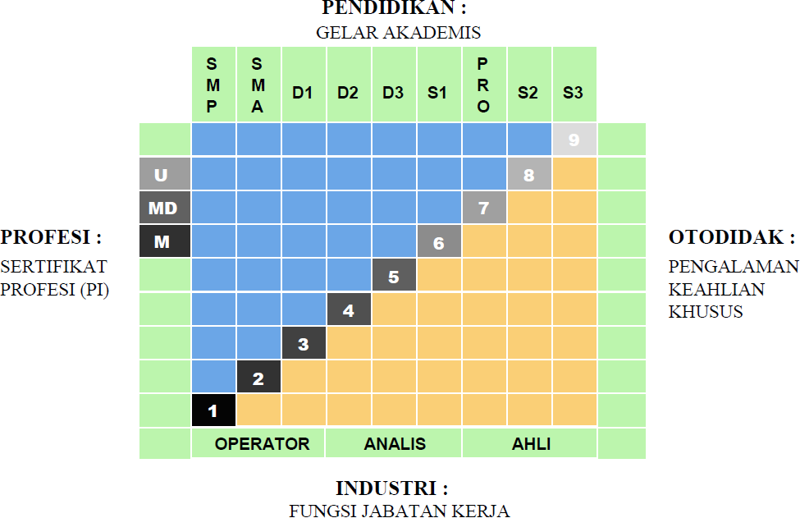

|  |  |
| --- | --- |
| * Kerangka Kualifikasi Nasional Indonesia, yang selanjutnya disingkat KKNI adalah kerangka penjenjangan kualifikasi kompetensi yang dapat menyandingkan, menyetarakan, dan mengintegrasikan antara bidang pendidikan dan bidang pelatihan kerja serta pengalaman kerja dalam rangka pemberian pengakuan kompetensi kerja sesuai dengan struktur pekerjaan di berbagai bidang. | * *KKNI as known as Indonesian Qualification Framework is a competence grading system which integrates the aspects of education, training, and working experience in purpose of acknowledging the capacity based on work qualification in various sectors.* |
| * KKNI merupakan perwujudan mutu dan jati diri bangsa Indonesia terkait dengan sistem pendidikan dan pelatihan nasional yang dimiliki Indonesia. | * *KKNI is the resemblance of Indonesian quality and identify concerning its national training and education system.* |
| * Jenjang kualifikasi adalah tingkat capaian pembelajaran yang disepakati secara nasional, disusun berdasarkan ukuran hasil pendidikan dan/atau pelatihan yang diperoleh melalui pendidikan formal, nonformal atau pengalaman kerja. | * *Qualification level, a nationally legalized learning outcomes, is composed by the results of education and training activities (formal, nonformal) or working experiences.*   SEMARANG, 24 OKTOBER 2023  DEKAN  *Dean*  Prof. Ir. Tri Winarni Agustini, M.Sc., Ph.D.  NIP 196508211990012001 |