**UNIVERSITAS DIPONEGORO**

*DIPONEGORO UNIVERSITY*

**FAKULTAS PERIKANAN DAN ILMU KELAUTAN**

*FACULTY OF FISHERIES AND MARINE SCIENCE*

**SURAT KETERANGAN PENDAMPING IJAZAH**

*DIPLOMA SUPPLEMENT*

**NOMOR*/****NUMBER****:* ---**

**Surat Keterangan Pendamping Ijazah menerangkan Capaian Pembelajaran dan Prestasi dari Pemegang Ijazah**

**Selama Masa Studi di Universitas Diponegoro**

*The Diploma Supplement Certifies Achievement of Its Bearer During the Period of Study at Diponegoro University*

|  |
| --- |
| **1. IDENTITAS DIRI** |
| *PERSONAL INFORMATION* |

|  |  |  |
| --- | --- | --- |
| 1.1 | **Nama Lengkap** |  |
|  | *Full Name* |

|  |  |  |
| --- | --- | --- |
| 1.2 | **Tempat & Tanggal Lahir** |  |
|  | *Place and Date of Birth* |

|  |  |  |
| --- | --- | --- |
| 1.3 | **Nomor Induk Kependudukan** | …………….. |
|  | *Identity Number* |

|  |  |  |
| --- | --- | --- |
| 1.4 | **Nomor Induk Mahasiswa** |  |
|  | *Student Number* |

|  |  |  |
| --- | --- | --- |
| 1.5 | **Tanggal Masuk** |  |
|  | *Admission Date* |

|  |  |  |
| --- | --- | --- |
| 1.6 | **Tanggal Lulus** |  |
|  | *Graduation Date* |

|  |  |  |
| --- | --- | --- |
| 1.7 | **Nomor Ijazah Nasional** | …….…… |
|  | *National Diploma Number* |

|  |  |  |
| --- | --- | --- |
| 1.8 | **Gelar** |  |
|  | *Title* |

|  |  |  |
| --- | --- | --- |
| 1.9 | **Lama Studi** |  |
|  | *Length of Study* |

|  |  |  |
| --- | --- | --- |
| 1.10 | **Sistem Kredit Semester** |  |
|  | *Credits* |

|  |  |  |
| --- | --- | --- |
| 1.11 | **Indeks Prestasi Kumulatif** |  |
|  |  |
|  | *Grade Point Average* |  |

|  |
| --- |
| **2. IDENTITAS INSTITUSI DAN PROGRAM STUDI** |
| *INSTITUTION AND STUDY PROGRAM* |

|  |  |  |
| --- | --- | --- |
| 2.1 | **Universitas** | Universitas Diponegoro |
|  | *University* |

|  |  |  |
| --- | --- | --- |
| 2.2 | **SK Pendirian Universitas** |  |
|  | *Government Decree of University Establishment* | Peraturan Pemerintah RI Nomor 7 Tahun 1961 |

|  |  |  |
| --- | --- | --- |
| 2.3 | **Akreditasi Institusi** | A |
|  | *Accreditation of University* |

|  |  |  |
| --- | --- | --- |
| 2.4 | **Jenis/Program Pendidikan Tinggi** | Akademik, Strata 1 |
|  | *Stratum* | *Academic, Bachelor Degree* |

|  |  |  |
| --- | --- | --- |
| 2.5 | **Program Studi** | Oseanografi |
|  | *Study Program* | *Oceanography* |

2.6 **Akreditasi Program**

**Studi** A

*Accreditation of study*

*program*

2.7 **Jenjang Kualifikasi KKNI** *Scheme Level in the Indonesian Qualification*

Level 6

*Framework*

2.8 **Persyaratan Penerimaan** Lulus SLTA dan Lulus Seleksi Mahasiswa Baru

*Admission Requirements High School graduate and passed student*

*admission selection*

|  |  |  |
| --- | --- | --- |
| 2.9 | **Bahasa Pengantar Kuliah** | Bahasa Indonesia  *Indonesian Language* |
|  | *Lingua Franca* |

|  |  |  |
| --- | --- | --- |
| 2.10 | **Sistem Penilaian** | Skala/*Scale*: 1- 4; A=4, B=3, C=2, D=1 |
|  | *Grading System* |

|  |  |  |
| --- | --- | --- |
| 2.11 | **Pendidikan Lanjut** | Program Magister & Doktoral |
|  | *Further Study* | *Master & Doctoral Program* |

|  |  |  |
| --- | --- | --- |
| 2.12 | **Status Profesi (Bila Ada)** |  |
|  | *Professional Status (If Applicable)* | -- |

|  |
| --- |
| **3. KUALIFIKASI DAN HASIL YANG DICAPAI** |
| *THE QUALIFICATION AND OUTCOMES OBTAINED* |

|  |  |  |
| --- | --- | --- |
| **A. CAPAIAN PEMBELAJARAN** |  | ***A. LEARNING OUTCOMES*** |
| Sarjana Sains  (KKNI Level 6) |  | *Bachelor of Science*  *(KKNI Level 6)* |
| **KEMAMPUAN DI BIDANG KERJA** |  | ***ABILITY IN THE FIELD OF WORK*** |
| Mampu menguasai ilmu dan teknologi dalam bidang Oseanografi dan mampu melakukan perencanaan, pengelolaan, dan lindungan terhadap lingkungan wilayah pesisir dan laut secara berkualitas dan berkelanjutan khususnya terhadap permasalahan mitigasi bencana, eksplorasi sumberdaya wilayah pesisir dan laut, serta kajian energi alternatif bahari dan samudra |  | *Having a comprehensive knowledge of science and technology of oceanography in order to be able to make plans, supervise and provide a quality and sustainable protection to the environment of coastal and marine region with disaster mitigation issues, exploration of coastal and marine resources, as well as study of marine and ocean energy* |
| **PENGETAHUAN YANG DIKUASAI** |  | ***ABILITY OF KNOWLEDGE*** |
| 1. Menguasai pengetahuan dasar-dasar tentang bidang ilmu Oseanografi (oseanografi fisika, oseanografi biologi, oseanografi kimia, oseanografi geologi, oseanografi perikanan) dalam mengidentifikasi, mendeskripsikan dan menjelaskan fenomena oseanografi di alam dan mendukung pemanfaatan energi alternatif bahari dan samudera. 2. Mampu melakukan analisis interaksi atmosfer dan laut, meteorologi dan klimatologi laut, penginderaan jauh dan pemetaan laut, sistem informasi geografis, akustik kelautan, untuk mendukung upaya eksplorasi sumberdaya wilayah pesisir dan laut, mitigasi bencana pesisir dan laut, serta sistem teknologi informasi digital. 3. Menguasai teknik-teknik pemrograman dan pemodelan oseanografi, serta mampu mengetahui proses hidrodinamika dan hidrolika, serta rekayasa oseanografi untuk mendukung pembangunan di pantai dan laut serta untuk melakukan mitigasi bencana di wilayah pesisir dan laut. 4. Mampu melakukan interaksi sosiologi masyarakat pesisir serta kewirausahaan. |  | 1. *Possessing a comprehensive basic knowledge of oceanography (physics oceanography, biological oceanography, chemical oceanography, geological oceanography, fisheries oceanography) to be able to identify, illustrate, and provide explanation of the emerging oceanographic phenomena and to support the use of marine and ocean energy* 2. *Having the ability to analyze the atmospheric and ocean interactions, marine meteorology and climatology, remote sensing as well as topography, geographic information system, marine acoustics to support the exploration efforts of coastal and marine resources, mitigation of coastal and marine disasters and digital information technology systems* 3. *Knowing the oceanographic programming and modeling techniques, the process of hydrodynamics and hydraulics, and oceanographic engineering to support the development of the beach and offshore as well as to carry out disaster mitigation in coastal and marine region* 4. *Having a sociological interaction and entrepreneurship with coastal communities* |
| **KEWENANGAN & TANGGUNG JAWAB** |  | ***AUTHORITY & RESPONSIBILITY*** |
| Mampu mengembangkan diri, tanggung jawab, percaya diri, bekerja dalam tim dan secara mandiri, memiliki kemampuan komunikasi efektif secara tertulis maupun lisan, berpikir kritis dan memanfaatkan berbagai sumber informasi dalam pemecahan masalah, memiliki etika dan integritas yang tinggi, serta memiliki karakter dan keinginan kuat untuk mengembangkan ilmu pengetahuan dan teknologi, serta mempunyai kemampuan yang COMPLETE (*Communicator, Professional, Leader, Enterpreneur, Thinker, dan Educator)* |  | *Having the ability for personal development, be liable, self-confidence, ability to work as a team and independent, having an effective communication skills both in writing and orally, critical thinking and utilize various sources of information in problem solving, high ethics and integrity, a strong and eager character to develop science and technology, as well as COMPLETE (Communicator, Professional, Leader, Entrepreneur, Thinker, and Educator) capabilities* |
| **B. PRESTASI DAN PENGHARGAAN** |  | ***B. ACHIEVEMENTS AND AWARDS*** |
| Pemegang Surat Keterangan Pendamping Ijazah ini memiliki sertifikat profesional: |  | *The bearer of this Diploma Supplement obtained the following professional certifications:* |
| *Diisi sesuai sertifikat kompetensi yang dimiliki mahasiswa ybs.* |  |  |
| **4. SKEMA TENTANG SISTEM PENDIDIKAN TINGGI DI INDONESIA** | | |
| ***SCHEME OF THE INDONESIAN HIGHER EDUCATION SYSTEM*** | | |

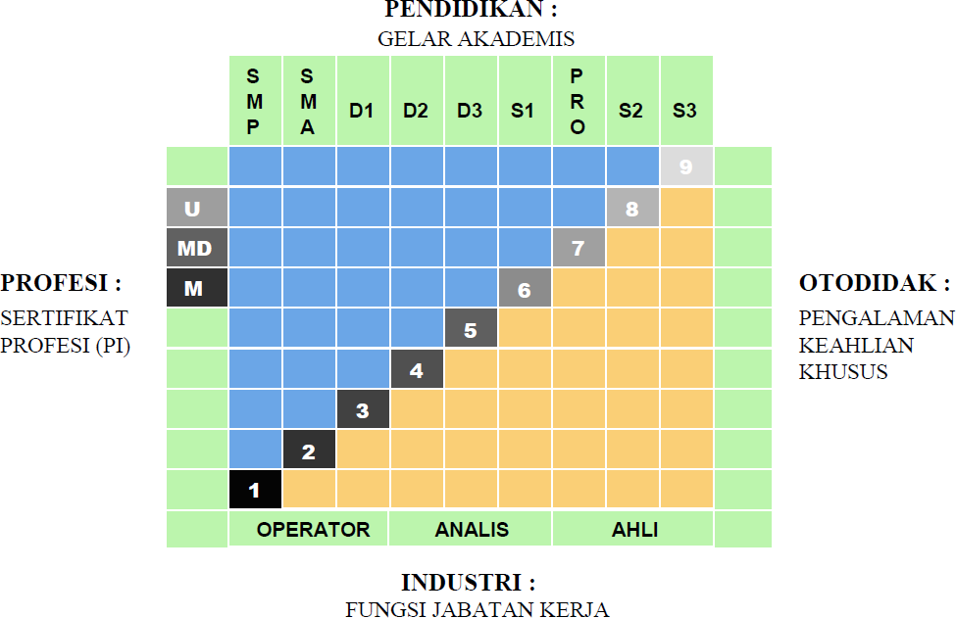

|  |  |
| --- | --- |
| * Kerangka Kualifikasi Nasional Indonesia, yang selanjutnya disingkat KKNI adalah kerangka penjenjangan kualifikasi kompetensi yang dapat menyandingkan, menyetarakan, dan mengintegrasikan antara bidang pendidikan dan bidang pelatihan kerja serta pengalaman kerja dalam rangka pemberian pengakuan kompetensi kerja sesuai dengan struktur pekerjaan di berbagai bidang. | * *KKNI as known as Indonesian Qualification Framework is a competence grading system which integrates the aspects of education, training, and working experience in purpose of acknowledging the capacity based on work qualification in various sectors.* |
| * KKNI merupakan perwujudan mutu dan jati diri bangsa Indonesia terkait dengan sistem pendidikan dan pelatihan nasional yang dimiliki Indonesia. | * *KKNI is the resemblance of Indonesian quality and identify concerning its national training and education system.* |
| * Jenjang kualifikasi adalah tingkat capaian pembelajaran yang disepakati secara nasional, disusun   berdasarkan ukuran hasil pendidikan dan/atau pelatihan  yang diperoleh melalui pendidikan formal, nonformal atau pengalaman kerja. | * *Qualification level, a nationally legalized learning outcomes, is composed by the results of education and training*   *activities (formal, nonformal) or working experiences.*  SEMARANG, 24 OKTOBER 2023  DEKAN  *Dean*  Prof. Ir. Tri Winarni Agustini, M.Sc., Ph.D.  NIP 196508211990012001 |