**UNIVERSITAS DIPONEGORO**

*DIPONEGORO UNIVERSITY*

**FAKULTAS PERIKANAN DAN ILMU KELAUTAN**

*FACULTY OF FISHERIES AND MARINE SCIENCE*

**SURAT KETERANGAN PENDAMPING IJAZAH**

*DIPLOMA SUPPLEMENT*

**NOMOR*/****NUMBER****:* ---**

**Surat Keterangan Pendamping Ijazah menerangkan Capaian Pembelajaran dan Prestasi dari Pemegang Ijazah**

**Selama Masa Studi di Universitas Diponegoro**

*The Diploma Supplement Certifies Achievement of Its Bearer During the Period of Study at Diponegoro University*

|  |
| --- |
| **1. IDENTITAS DIRI** |
| *PERSONAL INFORMATION* |

|  |  |  |
| --- | --- | --- |
| 1.1 | **Nama Lengkap** |  |
|  | *Full Name* |

|  |  |  |
| --- | --- | --- |
| 1.2 | **Tempat & Tanggal Lahir** |  |
|  | *Place and Date of Birth* |

|  |  |  |
| --- | --- | --- |
| 1.3 | **Nomor Induk Kependudukan** |  |
|  | *Identity Number* |

|  |  |  |
| --- | --- | --- |
| 1.4 | **Nomor Induk Mahasiswa** |  |
|  | *Student Number* |

|  |  |  |
| --- | --- | --- |
| 1.5 | **Tanggal Masuk** |  |
|  | *Admission Date* |

|  |  |  |
| --- | --- | --- |
| 1.6 | **Tanggal Lulus** |  |
|  | *Graduation Date* |

|  |  |  |
| --- | --- | --- |
| 1.7 | **Nomor Ijazah Nasional** |  |
|  | *National Diploma Number* |

|  |  |  |
| --- | --- | --- |
| 1.8 | **Gelar** |  |
|  | *Title* |

|  |  |  |
| --- | --- | --- |
| 1.9 | **Lama Studi** |  |
|  | *Length of Study* |

|  |  |  |
| --- | --- | --- |
| 1.10 | **Sistem Kredit Semester** |  |
|  | *Credits* |

|  |  |  |
| --- | --- | --- |
| 1.11 | **Indeks Prestasi Kumulatif** |  |
|  |  |
|  | *Grade Point Average* |  |

|  |
| --- |
| **2. IDENTITAS INSTITUSI DAN PROGRAM STUDI** |
| *INSTITUTION AND STUDY PROGRAM* |

|  |  |  |
| --- | --- | --- |
| 2.1 | **Universitas** | Universitas Diponegoro  *Diponegoro University* |
|  | *University* |

|  |  |  |
| --- | --- | --- |
| 2.2 | **SK Pendirian Universitas** |  |
|  | *Government Decree of University Establishment* | Peraturan Pemerintah RI Nomor 7 Tahun 1961  *Republic of Indonesia Government Regulation Number 7 of 1961* |

|  |  |  |
| --- | --- | --- |
| 2.3 | **Akreditasi Institusi** | A |
|  | *Accreditation of University* |

|  |  |  |
| --- | --- | --- |
| 2.4 | **Jenis/Program Pendidikan Tinggi** | Akademik, Strata 1 |
|  | *Stratum* | *Academic, Bachelor Degree* |

|  |  |  |
| --- | --- | --- |
| 2.5 | **Program Studi** | Manajemen Sumberdaya Perairan |
|  | *Study Program* | *Aquatic Resources Management* |

|  |  |  |
| --- | --- | --- |
| 2.6 | **Akreditasi Program Studi** | A |
|  | *Accreditation of study*  *program* |  |

|  |  |  |
| --- | --- | --- |
| 2.7 | **Jenjang Kualifikasi KKNI** | Level 6 |
|  | *Scheme Level in the*  *Indonesian Qualification* | *Level 6* |
|  | *Framework* |  |

|  |  |  |
| --- | --- | --- |
| 2.8 | **Persyaratan Penerimaan** | Lulus SLTA dan Lulus Seleksi Mahasiswa Baru |
|  | *Admission Requirements* | *High School graduate and passed student admission*  *selection* |

|  |  |  |
| --- | --- | --- |
| 2.9 | **Bahasa Pengantar Kuliah** | Bahasa Indonesia  *Indonesian Language* |
|  | *Lingua Franca* |

|  |  |  |
| --- | --- | --- |
| 2.10 | **Sistem Penilaian** | Skala/*Scale*: 1- 4; A=4, B=3, C=2, D=1 |
|  | *Grading System* |

|  |  |  |
| --- | --- | --- |
| 2.11 | **Pendidikan Lanjut** | Program Magister & Doktoral |
|  | *Further Study* | *Master & Doctoral Program* |

|  |  |  |
| --- | --- | --- |
| 2.12 | **Status Profesi (Bila Ada)** |  |
|  | *Professional Status (If Applicable)* | -- |

|  |
| --- |
| **3. KUALIFIKASI DAN HASIL YANG DICAPAI** |
| *THE QUALIFICATION AND OUTCOMES OBTAINED* |

|  |  |  |
| --- | --- | --- |
| **A. CAPAIAN PEMBELAJARAN** |  | ***A. LEARNING OUTCOMES*** |
| Sarjana Perikanan  (KKNI Level 6) |  | *Fisheries Bachelor Level (KKNI Level 6)* |
| **KEMAMPUAN DI BIDANG KERJA** |  | ***ABILITY IN THE FIELD OF WORK*** |
| Mampu merencanakan, mengaplikasikan dan mengevaluasi pengelolaan sumberdaya perikanan dan lingkungan perairan secara berkelanjutan dengan pendekatan ekosistem |  | *Able to plan, apply and evaluate the management of fisheries resources and aquatic environment in a sustainable manner with an ecosystem approach* |
| **PENGETAHUAN YANG DIKUASAI** |  | ***ABILITY OF KNOWLEDGE*** |
| Menguasai konsep dan prinsip pengelolaan sumberdaya perikanan dan lingkungan perairan (prinsip, tipologi dan ilmu manajemen sumberdaya perairan dan perikanan, ilmu kesehatan lingkungan perairan, konservasi sumberdaya hayati perairan, kebijakan dan peraturan perundangan terkait pengelolaan sumberdaya perairan) serta dapat memanfaatkannya dalam berkarya |  | *Able the concept and principles of fisheries resources management and aquatic environment (principles, typology and aquatic resources and fisheries science, aquatic environmental health science, marine biological resources conservation, policies and regulations related to aquatic resources management) and it’s applicated* |
| **KEWENANGAN & TANGGUNG JAWAB** |  | ***AUTHORITY & RESPONSIBILITY*** |
| Mampu mengambi keputusan dalam memilih alternatif pengelolaan sumberdaya perikanan dan lingkungan perairan secara ilmiah, mandiri dan bekerjasama |  | *Able to take decisions in choosing fisheries and aquatic resources management alternatives scientifically, independently and team work* |
| **B. PRESTASI DAN PENGHARGAAN** |  | ***B. ACHIEVEMENTS AND AWARDS*** |
| Pemegang Surat Keterangan Pendamping Ijazah ini memiliki sertifikat professional : |  | *The bearer of this Diploma Supplement obtained the following professional certifications:* |
| *Diisi sesuai sertifikat kompetensi yang dimiliki mahasiswa ybs.* |  |  |
| **4. SKEMA TENTANG SISTEM PENDIDIKAN TINGGI DIINDONESIA** | | |
| ***SCHEME OF THE INDONESIAN HIGHER EDUCATION SYSTEM*** | | |

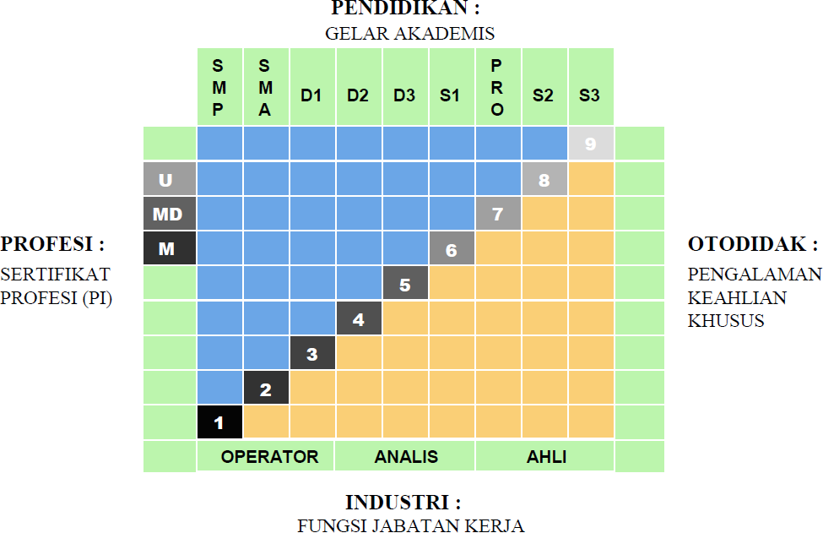

|  |  |
| --- | --- |
| * Kerangka Kualifikasi Nasional Indonesia, yang selanjutnya disingkat KKNI adalah kerangka penjenjangan kualifikasi kompetensi yang dapat menyandingkan, menyetarakan, dan mengintegrasikan antara bidang pendidikan dan bidang pelatihan kerja serta pengalaman kerja dalam rangka pemberian pengakuan kompetensi kerja sesuai dengan struktur pekerjaan di berbagai bidang. | * *KKNI as known as Indonesian Qualification Framework is a competence grading system which integrates the aspects of education, training, and working experience in purpose of acknowledging the capacity based on work qualification in various sectors.* |
| * KKNI merupakan perwujudan mutu dan jati diri bangsa Indonesia terkait dengan sistem pendidikan dan pelatihan nasional yang dimiliki Indonesia. | * *KKNI is the resemblance of Indonesian quality and identify concerning its national training and education system.* |
| * Jenjang kualifikasi adalah tingkat capaian pembelajaran yang disepakati secara nasional, disusun berdasarkan ukuran hasil pendidikan dan/atau pelatihan yang diperoleh melalui pendidikan formal, nonformal atau pengalaman kerja. | * *Qualification level, a nationally legalized learning outcomes, is composed by the results of education and training activities (formal, nonformal) or working experiences.*   SEMARANG, 24 OKTOBER 2023  DEKAN  *Dean*  Prof. Ir. Tri Winarni Agustini, M.Sc., Ph.D.  NIP 196508211990012001 |