**UNIVERSITAS DIPONEGORO**

*DIPONEGORO UNIVERSITY*

**FAKULTAS PERIKANAN DAN ILMU KELAUTAN**

*FACULTY OF FISHERIES AND MARINE SCIENCE*

**SURAT KETERANGAN PENDAMPING IJAZAH**

*DIPLOMA SUPPLEMENT*

**NOMOR*/****NUMBER****:* ---**

**Surat Keterangan Pendamping Ijazah menerangkan Capaian Pembelajaran dan Prestasi dari Pemegang Ijazah**

**Selama Masa Studi di Universitas Diponegoro**

*The Diploma Supplement Certifies Achievement of Its Bearer During the Period of Study at Diponegoro University*

|  |
| --- |
| **1. IDENTITAS DIRI** |
| *PERSONAL INFORMATION* |

|  |  |  |
| --- | --- | --- |
| 1.1 | **Nama Lengkap** |  |
|  | *Full Name* |

|  |  |  |
| --- | --- | --- |
| 1.2 | **Tempat&Tanggal Lahir** |  |
|  | *Place and Date of Birth* |

|  |  |  |
| --- | --- | --- |
| 1.3 | **Nomor Induk Kependudukan** | …………….. |
|  | *Identity Number* |

|  |  |  |
| --- | --- | --- |
| 1.4 | **Nomor Induk Mahasiswa** |  |
|  | *Student Number* |

|  |  |  |
| --- | --- | --- |
| 1.5 | **Tanggal Masuk** |  |
|  | *Admission Date* |

|  |  |  |
| --- | --- | --- |
| 1.6 | **Tanggal Lulus** |  |
|  | *Graduation Date* |

|  |  |  |
| --- | --- | --- |
| 1.7 | **Nomor Ijazah Nasional** | …….…… |
|  | *National Diploma Number* |

|  |  |  |
| --- | --- | --- |
| 1.8 | **Gelar** |  |
|  | *Title* |

|  |  |  |
| --- | --- | --- |
| 1.9 | **Lama Studi** |  |
|  | *Length of Study* |

|  |  |  |
| --- | --- | --- |
| 1.10 | **Sistem Kredit Semester** |  |
|  | *Credits* |

|  |  |  |
| --- | --- | --- |
| 1.11 | **Indeks Prestasi Kumulatif** |  |
|  |  |
|  | *Grade Point Average* |  |

|  |
| --- |
| **2. IDENTITAS INSTITUSI DAN PROGRAM STUDI** |
| *INSTITUTION AND STUDY PROGRAM* |

|  |  |  |
| --- | --- | --- |
| 2.1 | **Universitas** | Universitas Diponegoro |
|  | *University* |

|  |  |  |
| --- | --- | --- |
| 2.2 | **SK Pendirian Universitas** |  |
|  | *Government Decree of University Establishment* | Peraturan Pemerintah RI Nomor 7 Tahun 1961 |

|  |  |  |
| --- | --- | --- |
| 2.3 | **Akreditasi Institusi** | A |
|  | *Accreditation of University* |

|  |  |  |
| --- | --- | --- |
| 2.4 | **Jenis/Program Pendidikan Tinggi** | Akademik, Strata 1 |
|  | *Stratum* | *Academic, Bachelor Degree* |

|  |  |  |
| --- | --- | --- |
| 2.5 | **Program Studi** | Ilmu Kelautan |
|  | *Study Program* | *Marine Science* |

2.6 **Akreditasi Program**

**Studi** A

*Accreditation of Study*

*Program*

2.7 **Jenjang Kualifikasi KKNI**

*Scheme Level in the Indonesian Qualification*

Level 6

*Framework*

2.8 **Persyaratan Penerimaan** Lulus SLTA dan Lulus Seleksi Mahasiswa Baru

*Admission Requirements High School graduate and passed student*

*Admission selection*

|  |  |  |
| --- | --- | --- |
| 2.9 | **Bahasa Pengantar Kuliah** | Bahasa Indonesia  *Indonesian Language* |
|  | *Lingua Franca* |

|  |  |  |
| --- | --- | --- |
| 2.10 | **SistemPenilaian** | Skala/*Scale*: 1- 4; A=4, B=3, C=2, D=1 |
|  | *Grading System* |

|  |  |  |
| --- | --- | --- |
| 2.11 | **Pendidikan Lanjut** | Program Magister&Doktoral |
|  | *Further Study* | *Master&Doctoral Program* |

|  |  |  |
| --- | --- | --- |
| 2.12 | **Status Profesi (Bila Ada)** |  |
|  | *Professional Status (If Applicable)* | -- |

|  |
| --- |
| **3. KUALIFIKASI DAN HASIL YANG DICAPAI** |
| *THE QUALIFICATION AND OUTCOMES OBTAINED* |

|  |  |  |
| --- | --- | --- |
| **A. CAPAIAN PEMBELAJARAN** |  | ***A. LEARNING OUTCOMES*** |
| Sarjana Sains  (KKNI Level 6) |  | *Bachelor of Science*  *(KKNI Level 6)* |
| **KEMAMPUAN DI BIDANG KERJA** |  | ***ABILITY IN THE FIELD OF WORK*** |
| Mampu menguasai ilmu dan teknologi dalam bidang kelautan yang meliputi penggunaan intrumentasi, metodE survei dan analisis data bio-fisik-kimia, uji mikrobiologis dan eksperimen bioteknologi untuk keperluan eksplorasi, eksploitasi, konservasi dan rehabilitasi (biota, habitat dan ekosistem) laut baik sebagai peneliti, pendidik maupun ahli konservasi. |  | *Mastering science and technology in the field of marine science which includes the use of instrumentation, survey methods and analysis of bio-physico-chemical data, microbiological analysis and biotechnological experiments for the purposes of exploration, conservation and rehabilitation (biota, habitat and ecosystem) as researchers, educator or conservationist.* |
| **PENGETAHUAN YANG DIKUASAI** |  | ***ABILITY OF KNOWLEDGE*** |
| 1. Menguasai pengetahuan dasar-dasar tentang bidang Ilmu Kelautan (Pengantar Ilmu Kelautan dan Perikanan, Biologi, Kimia Dasar, Oseanografi, Biokimia, Selam, Botani Laut, Ekologi Lau tTropis). 2. Menguasai metode pengambilan data bio-fisik dan kimia laut (data karang, ikan, lamun, mangrove, plankton, dan parameter lingkungan lain). 3. Mampu melakukan observasi, eksperimen dan analisis kimiawi serta bioteknologi untuk mendukung upaya eksplorasi dan konservasi sumber daya laut. 4. Mampu melakukan interaksi sosiologi masyarakat pesisir serta kewirausahaan. |  | 1. *Mastering the basic knowledge of Marine Sciences (Marine Biology, Chemistry, Oceanography, Biochemistry, Marine Botany, Tropical Marine Ecology).* 2. *Mastering the methods for collecting bio-physical and chemical marine data (data of coral, fishes, seagrass, mangrove, plankton, and other environmental parameters).* 3. *Able to conduct observations, experiments and analysis on chemistry and biotechnology to support the exploration and conservation of the marine resources.* 4. *Having a sociological interaction and entrepreneurship with coastal communities.* |
| **KEWENANGAN&TANGGUNG JAWAB** |  | ***AUTHORITY&RESPONSIBILITY*** |
| Mampu mengembangkan diri, tanggungjawab, percaya diri, bekerja dalam tim dan secara mandiri, memiliki kemampuan komunikasi efektif secara tertulis maupun lisan, berpikir kritis dan memanfaatkan berbagai sumber informasi dalam pemecahan masalah, memiliki etika dan integritas yang tinggi, serta memiliki karakter dan keinginan kuat untuk mengembangkan ilmu pengetahuan dan teknologi, serta mempunyai kemampuan yang COMPLETE (*Communicator, Professional, Leader, Enterpreneur, Thinker, dan Educator).* |  | *Having the ability for personal development, be liable, self-confidence, ability to work as a team and independent, having an effective communication skills both in writing and orally, critical thinking and utilize various sources of information in problem solving, high ethics and integrity, a strong and eager character to develop science and technology, as well as COMPLETE (Communicator, Professional, Leader, Entrepreneur, Thinker, and Educator) capabilities.* |
| **B. PRESTASI DAN PENGHARGAAN** |  | ***B. ACHIEVEMENTS AND AWARDS*** |
| Pemegang Surat Keterangan Pendamping Ijazah ini memiliki sertifikat profesional: |  | *The bearer of this Diploma Supplement obtained the following professional certifications:* |
| *Diisi sesuai sertifikat kompetensi yang dimiliki mahasiswa ybs.* |  |  |
| **4. SKEMA TENTANG SISTEM PENDIDIKAN TINGGI DIINDONESIA** | | |
| ***SCHEME OF THE INDONESIAN HIGHER EDUCATION SYSTEM*** | | |

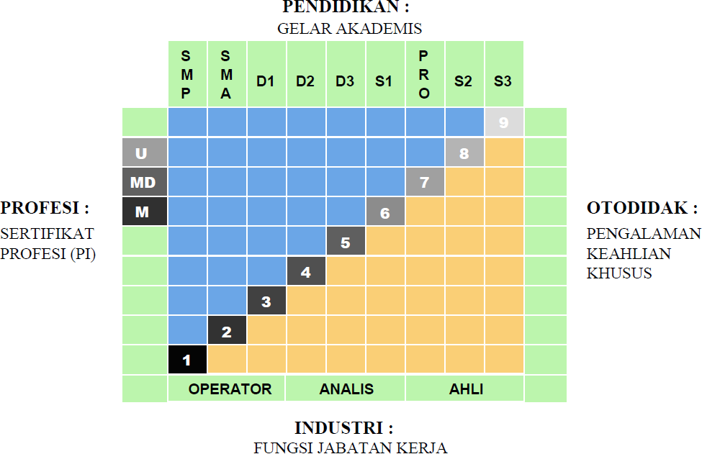

|  |  |
| --- | --- |
| * Kerangka Kualifikasi Nasional Indonesia, yang selanjutnya disingkat KKNI adalah kerangka penjenjangan kualifikasi kompetensi yang dapat menyandingkan, menyetarakan, dan mengintegrasikan antara bidan gpendidikan dan bidang pelatihan kerja serta pengalaman kerja dalam rangka pemberian pengakuan kompetensi kerja sesuai dengan struktur pekerjaan di berbagai bidang. | * *KKNI as known as Indonesian Qualification Framework is a competence grading system which integrates the aspects of education, training, and working experience in purpose of acknowledging the capacity based on work qualification in various sectors.* |
| * KKNI merupakan perwujudan mutu dan jati diri bangsa Indonesia terkait dengan system pendidikan dan pelatihan nasional yang dimiliki Indonesia. | * *KKNI is the resemblance of Indonesian quality and identify concerning its national training and education system.* |
| * Jenjang kualifikasi adalah tingkat capaian pembelajaran yang disepakati secara nasional, disusun   berdasarkan ukuran hasil pendidikan dan/atau pelatihan yang diperoleh melalui pendidikan formal, nonformal atau pengalaman kerja. | * *Qualification level, anationally legalized learning outcomes, is composed by the results of education and training activities (formal, nonformal) or working experiences.*   SEMARANG, 24 OKTOBER 2023  DEKAN  *Dean*  Prof. Ir. Tri Winarni Agustini, M.Sc., Ph.D.  NIP 196508211990012001 |