**UNIVERSITAS DIPONEGORO**

*DIPONEGORO UNIVERSITY*

**FAKULTAS PERIKANAN DAN ILMU KELAUTAN**

*FACULTY OF FISHERIES AND MARINE SCIENCE*

**SURAT KETERANGAN PENDAMPING IJAZAH**

*DIPLOMA SUPPLEMENT*

**NOMOR*/****NUMBER****:***

**Surat Keterangan Pendamping Ijazah menerangkan Capaian Pembelajaran dan Prestasi dari Pemegang Ijazah**

**Selama Masa Studi di Universitas Diponegoro**

*The Diploma Supplement Certifies Achievement of Its Bearer During the Period of Study at Diponegoro University*

|  |
| --- |
| **1. IDENTITAS DIRI** |
| *PERSONAL INFORMATION* |

|  |  |  |
| --- | --- | --- |
| 1.1 | **Nama Lengkap** |  |
|  | *Full Name* |

|  |  |  |
| --- | --- | --- |
| 1.2 | **Tempat & Tanggal Lahir** |  |
|  | *Place and Date of Birth* |

|  |  |  |
| --- | --- | --- |
| 1.3 | **Nomor Induk Kependudukan** | …………….. |
|  | *Identity Number* |

|  |  |  |
| --- | --- | --- |
| 1.4 | **Nomor Induk Mahasiswa** |  |
|  | *Student Number* |

|  |  |  |
| --- | --- | --- |
| 1.5 | **Tanggal Masuk** |  |
|  | *Admission Date* |

|  |  |  |
| --- | --- | --- |
| 1.6 | **Tanggal Lulus** |  |
|  | *Graduation Date* |

|  |  |  |
| --- | --- | --- |
| 1.7 | **Nomor Ijazah Nasional** | …….…… |
|  | *National Diploma Number* |

|  |  |  |
| --- | --- | --- |
| 1.8 | **Gelar** | Sarjana Perikanan (S.Pi) |
|  | *Title* |

|  |  |  |
| --- | --- | --- |
| 1.9 | **Lama Studi** |  |
|  | *Length of Study* |

|  |  |  |
| --- | --- | --- |
| 1.10 | **Sistem Kredit Semester** | 144 sks |
|  | *Credits* |

|  |  |  |
| --- | --- | --- |
| 1.11 | **Indeks Prestasi Kumulatif** |  |
|  |  |
|  | *Grade Point Average* |  |

|  |
| --- |
| **2. IDENTITAS INSTITUSI DAN PROGRAM STUDI** |
| *INSTITUTION AND STUDY PROGRAM* |

|  |  |  |
| --- | --- | --- |
| 2.1 | **Universitas** | Universitas Diponegoro |
|  | *University* |

|  |  |  |
| --- | --- | --- |
| 2.2 | **SK Pendirian Universitas** |  |
|  | *Government Decree of University Establishment* | Peraturan Pemerintah RI Nomor 7 Tahun 1961 |

|  |  |  |
| --- | --- | --- |
| 2.3 | **Akreditasi Institusi** | A |
|  | *Accreditation of University* |

|  |  |  |
| --- | --- | --- |
| 2.4 | **Jenis/Program Pendidikan Tinggi** | Akademik, Strata 1 |
|  | *Stratum* | *Academic, Bachelor Degree* |

|  |  |  |
| --- | --- | --- |
| 2.5 | **Program Studi** | Akuakultur |
|  | *Study Program* | *A q u a c u l t u r e* |

2.6 **Akreditasi Program**

**Studi** Unggul

*Accreditation of study*

*program*

2.7 **Jenjang Kualifikasi KKNI** *Scheme Level in the Indonesian Qualification*

Level 6

*Framework*

2.8 **Persyaratan Penerimaan** Lulus SLTA dan Lulus Seleksi Mahasiswa **Baru**

*Admission Requirements High School graduate and passed student*

*admission selection*

|  |  |  |
| --- | --- | --- |
| 2.9 | **Bahasa Pengantar Kuliah** | Bahasa Indonesia  *Indonesian Language* |
|  | *Lingua Franca* |

|  |  |  |
| --- | --- | --- |
| 2.10 | **Sistem Penilaian** | Skala/*Scale*: 1- 4; A=4, B=3, C=2, D=1 |
|  | *Grading System* |

|  |  |  |
| --- | --- | --- |
| 2.11 | **Pendidikan Lanjut** | Program Magister&Doktoral |
|  | *Further Study* | *Master&Doctoral Program* |

|  |  |  |
| --- | --- | --- |
| 2.12 | **Status Profesi (Bila Ada)** |  |
|  | *Professional Status (If Applicable)* | -- |

|  |
| --- |
| **3. KUALIFIKASI DAN HASIL YANG DICAPAI** |
| *THE QUALIFICATION AND OUTCOMES OBTAINED* |

|  |  |  |
| --- | --- | --- |
| **A. CAPAIAN PEMBELAJARAN** |  | ***A. LEARNING OUTCOMES*** |
| Sarjana Perikanan: Akuakultur (KKNI Level 6) |  | *Aquaculture Bachelor Level (KKNI Level 6)* |
| **KEMAMPUAN DI BIDANG KERJA** |  | ***ABILITY IN THE FIELD OF WORK*** |
| Mampu menentukan metode budidaya ikan menurut prinsip-prinsip budidaya berkelanjutan, ramah lingkungan dan mampu menganalisis dan menentukan lokasi budidaya ikan yang baik. |  | *Able to determine aquaculture methods according to the principles of sustainable, environmentally friendly cultivation and able to analyze and determine the location of good fish farming.* |
| **PENGETAHUAN YANG DIKUASAI** |  | ***ABILITY OF KNOWLEDGE*** |
| Menguasai prinsip budidaya perairan dan kepemimpinan usaha budidaya yang berkelanjutan, berwawasan lingkungan/ramah lingkungan dan menguasai prinsip dasar bisnis akuakultur. |  | *Mastering the principles of aquaculture and leadership in a sustainable, environmentally friendly/environmentally friendly aquaculture business and mastering the basic principles of the aquaculture business.* |
| **KEWENANGAN & TANGGUNG JAWAB** |  | ***AUTHORITY & RESPONSIBILITY*** |
| Memiliki kemampuan untuk mengerti, menerima, menciptakan dan mengelola gagasan/konsep penemuan/pengembangan budidaya perairan yang ramah lingkungan yang berkelanjutan dan mampu menempatkan diri sebagai pembelajar, pelaksana dan panutan berdasarkan ilmu dan pengalaman yang dimiliki dalam industri budidaya nasional maupun internasional. |  | *Having the ability to understand, accept, create and manage ideas/ concepts of discovery/ development of aquaculture that is environmentally friendly and sustainable and able to place themselves as learners, executor, and role model based on the knowledge and experience in the aquaculture industry nationally and internationally.* |
| **B. PRESTASI DAN PENGHARGAAN** |  | ***B. ACHIEVEMENTS AND AWARDS*** |
| Pemegang Surat Keterangan Pendamping Ijazah ini memiliki sertifikat profesional: |  | *The bearer of this Diploma Supplement obtained the following professional certifications:* |
| *Diisi sesuai sertifikat kompetensi yang dimiliki mahasiswa ybs.* |  |  |
| **4. SKEMA TENTANG SISTEM PENDIDIKAN TINGGI DI INDONESIA** | | |
| ***SCHEME OF THE INDONESIAN HIGHER EDUCATION SYSTEM*** | | |

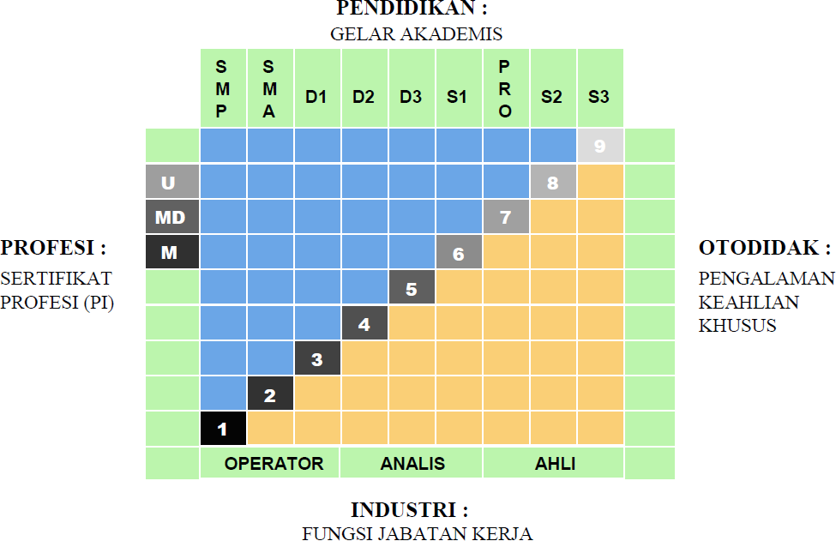

|  |  |
| --- | --- |
| * Kerangka Kualifikasi Nasional Indonesia, yang selanjutnya disingkat KKNI adalah kerangka penjenjangan kualifikasi kompetensi yang dapat menyandingkan, menyetarakan, dan mengintegrasikan antara bidang pendidikan dan bidang pelatihan kerja serta pengalaman kerja dalam rangka pemberian pengakuan kompetensi kerja sesuai dengan struktur pekerjaan di berbagai bidang. | * *KKNI as known as the Indonesian Qualification Framework, is a competency grading system that integrates the aspects of education, training, and working experience in the purpose of acknowledging the capacity based on work qualification in various sectors.* |
| * KKNI merupakan perwujudan mutu dan jati diri bangsa Indonesia terkait dengan sistem pendidikan dan pelatihan nasional yang dimiliki Indonesia. | * *KKNI is the resemblance of Indonesian quality and identifies concerning its national training and education system.* |
| * Jenjang kualifikasi adalah tingkat capaian pembelajaran yang disepakati secara nasional, disusun   berdasarkan ukuran hasil pendidikan dan/atau pelatihan  yang diperoleh melalui pendidikan formal, nonformal atau pengalaman kerja. | * *Qualification level, a nationally legalized learning outcomes, is composed of the results of education and training*   *activities (formal, nonformal) or working experiences.*  SEMARANG, 24 OKTOBER 2023  DEKAN  *Dean*  Prof. Ir. Tri Winarni Agustini, M.Sc., Ph.D.  NIP 196508211990012001 |